**IRS 1095-B Tax Form (Health Coverage)**

Table of Contents

IRS 1095-B Tax Form Overview 2

User Access 2

Who can access this form? 2

Navigation 3

1095-B Download Functionality 4

Part 1: Access the form 4

Part 2: The 1095-B Health Coverage Form 6

Paperless Delivery 7

Escalation Path 8

Errors & Notifications 10

# IRS 1095-B Tax Form Overview

IRS Form 1095-B reports the months a person had qualifying minimum health coverage to the IRS. Currently the VA mails this form out to Veterans at the beginning of the year (between December and March). The process is costly, and many are returned to due inaccurate address. In order to ensure delivery to Veterans and to decrease some of the costs associated with mailing this form, we have now made the 1095-B available for online access via digital download of a pdf from their records on Va.gov.

Changes to the Affordable Care Act have reduced the federal tax penalty for not having health coverage to $0; so, in most cases the 1095-B will simply be a document to keep for one's records. As of March 2022, six states—Massachusetts, New Jersey, Vermont, California, Rhode Island and District of Columbia (Washington D.C.)—still have individual coverage mandates that may result in penalties for not being insured and so Veterans should refer to any local IRS instructions, as applicable, for retaining this form and filing their state taxes.

Target launch date: September 2022 for MVP

## User Access

### Who can access this form?

Veterans enrolled in VA health benefits with a VA.gov account.

**How can users access this form?**

Users can log in using their DS Logon Premium, MHV Premium, or ID.me accounts.

## Navigation

**Direct url:** <https://www.va.gov/records/download-your-irs-1095-b>

**Or** the link to download the IRS 1095-B tax form can be found by way of the VA Benefits and Health Care dropdown menu (top navigation) on the Records Hub Page: <https://www.va.gov/records/>

By clicking “view all in records,” the Veteran can then find the link labeled “Download your IRS 1095-B tax form.”

# 1095-B Download Functionality

## Part 1: Access the form

**(If not signed in)**

If the Veteran navigates to the form while not logged in, they will be prompted to do so on the page.

**(If already signed in)**

Once the Veteran is on the page, they will have an option to choose the format of their  
document download. Options are provided for PDF or Text file. PDF is a common document  
format that mimics the look of the paper form and is easily printable. Text is an approved IRS  
alternate document format that works well for those who may be using a screen reader or  
other assistive technology.

After the Veteran has selected the radio button for their desired document format, they can  
click the blue primary action button, “Download your 1095-B tax form.”

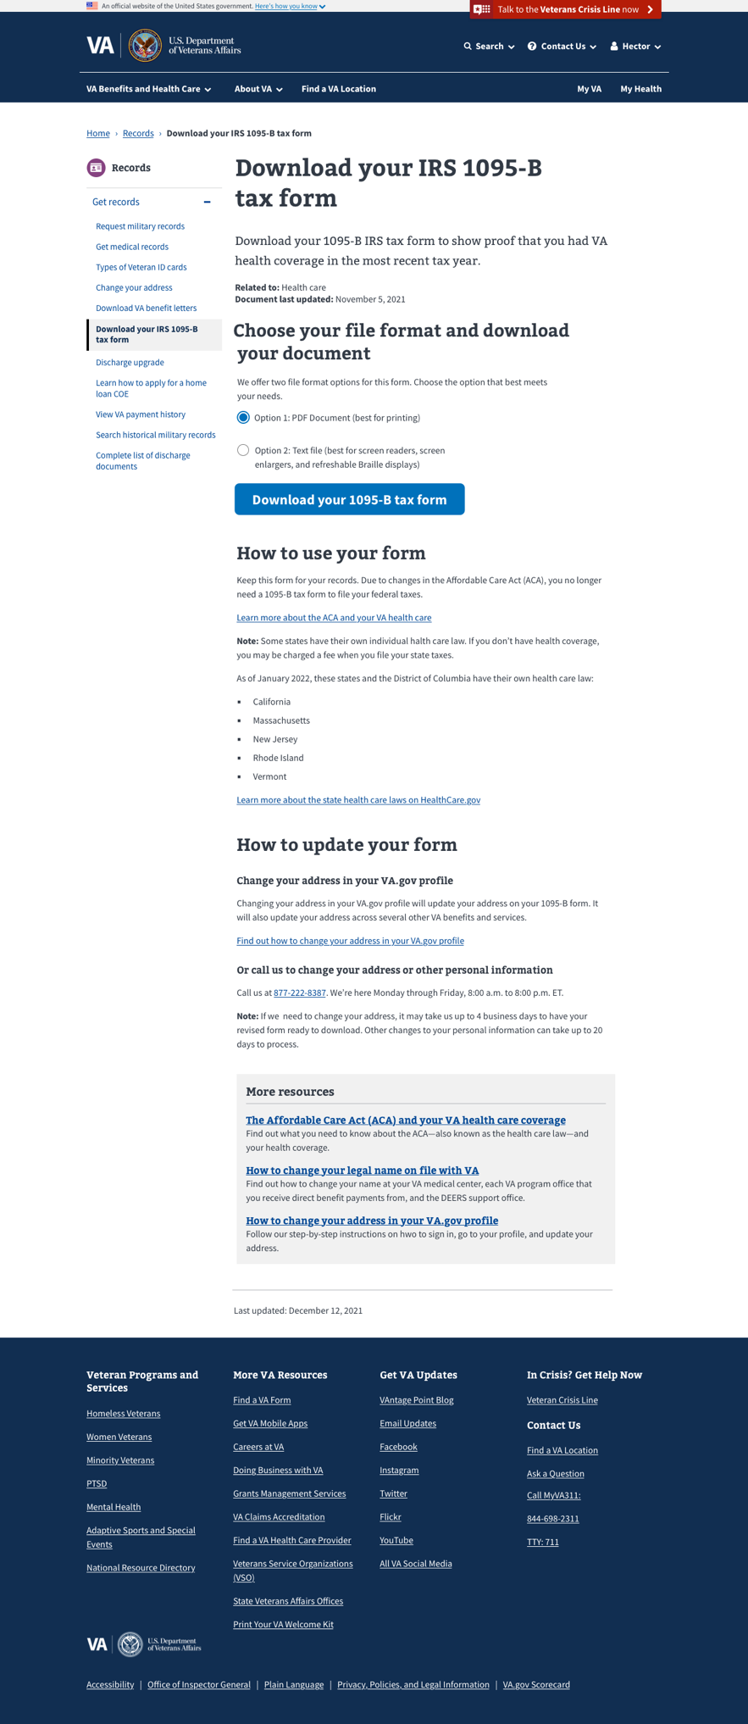

## Part 2: The 1095-B Health Coverage Form

The 1095-B is pre-populated with all of the Veteran’s information: name, social security number, address and months of coverage. Provided are examples of the PDF version (option 1, best for printing) of the document and Text file (option 2, best for screen readers, screen enlargers, and refreshable Braille displays) respectively.

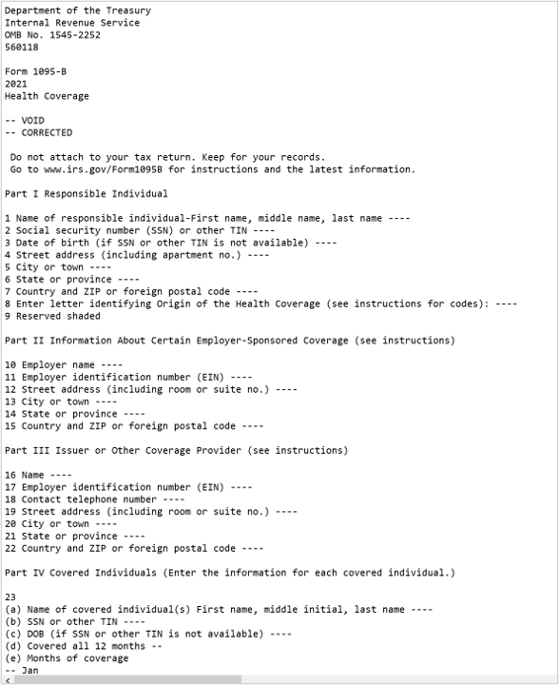

## Paperless Delivery

In order to reduce paper waste and costs associated with mailing the 1095-B, an option for paperless delivery only is being made available to Veterans. On the 1095-B landing page, below the download button inside of a gray information box is a callout for “Sign up for paperless delivery.” A Veteran may select the linked action button here to be redirected to their VA.gov profile where they can choose how they would like to receive their 1095-B—in the mail or digital. They can also complete this task by navigating to their profile directly via the top navigation. Once a Veteran has opted-in for paperless delivery only, they will no longer receive the 1095-B in the mail until this setting is changed again.

## Escalation Path

If a Veteran notices an incorrect address on their 1095-B, they can update this information in their VA.gov profile and download a new form —a link to how to do this is included on the landing page, under the section, “How to update your form.” Veterans can also call the Health Benefits Hotline at 1-877-222-8387 to update their address and/or fix any additional errors noticed on the form. Once a representative answers the phone, the Veteran should tell them that there is an error on their 1095-B form. The representative will ask for the correct information and update it in the enrollment system.

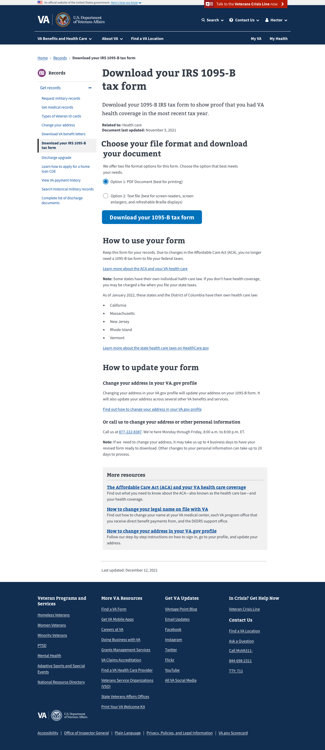

Veterans should refer to the “Document last updated” date above the 1095-B download link to make sure that they are downloading the most recent version of the form. Changes to a Veteran’s address may take up to 4 business days to process and generate a new version of 1095-B online. Changes to other personal information outside of mailing address, such as corrections to date of birth or social security number take additional processing time and may take up to 20 business days for the Veteran to receive an updated copy of their 1095-B.

## Errors & Notifications

In most cases, after clicking the download button Veterans will know that they have successfully downloaded the 1095-B by a change in state—the text above the box will now read “Download complete.”

However, in certain cases the Veteran may not be able to download their 1095-B as expected. If they have just registered for health care with the VA and do not have data on file for the previous year, they will receive the following message:

If there is a technical error on the site and the form is not able to be generated, the Veteran will receive this message:

